Predictive shapes Basic Tool Help

**Summary**

The predictive shapes tool uses a set time frame to generate a specified shape (a truncated ellipse) for each time stamp in the data set. This tool is intended to be used with data as requested from the SunEdison Wind Turbine Data Centers. The semimajor axis is defined by the proportion of the wind speed to max wind speed multiplied by the maximum search distance. The semiminor axis is the rotor diameter. The shape is then clipped to a box bounded by 10m in front of the rotor to the maximum search distance behind the rotor.

**Details**

This tool is intended to be used with CSV data to create shapefiles.

Fatality data is used to: select weather data by date, and to create a shapefile for comparison with the predictive shapes. All X,Y data should be relative to 0,0.

Fatality data must be input in a CSV. Best practice is to exclude titles. The following is an example:

Date_A,CommonName,Northing,Easting,Quadrant,Siteturbin

5/1/2015,Lonchura punctulata (Nutmeg Mannikin),-16.9894,12.34359,2,KAW01-25

11/27/2012,Lonchura cantans (African Silverbill),5.5668,-39.6108,4,KAW01-24

Date – must be in the format MM/DD/YYYY

Species – Text format

Northing/Easting – Coordinates based on a distance and direction to 0,0. If the fatality was found 20m north the equation for the coordinates are Y=20*cos(0) X = 20*sin(0)

Quadrant – reference to the cardinal direction, not required but the field must be included

Siteturbin – An identifier for the fatality that will be used to compare shapes to Fatality

Weather data: Each weather data line has an ID, a timestamp, a wind speed and direction.

Weather data must be input in a CSV. Best practice is to exclude titles, all columns must be included. The following is an example:

ID1,TimeStamp,WindSpeed,Yaw,Site,Turbine,Site-turbine

1,9/14/2012 02:00,3.246932,19.1,Kawailoa,26,KAW01-26

2,9/14/2012 02:10,7.867995,26.21504,Kawailoa,26,KAW01-26

ID – A line ID

Timestamp – Must be in the format MM/DD/YYYY HH:MM

Wind speed – Wind speed at the nacelle in meters per second

Yaw – Angle of the turbine facing into the wind.

Site – Location

Turbine – Turbine name/number

Site turbine – An identifier for the fatality that will be used to compare shapes to Fatality

Rotor Radius – i.e. blade length (figure 1)

Nacelle height – Height above ground (figure 1)

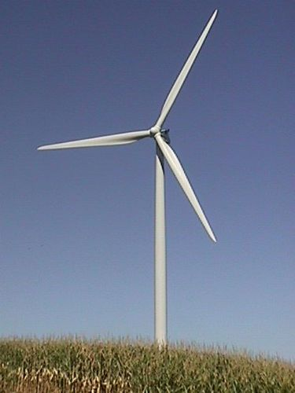

Nacelle

Height

Nacelle

Rotor Radius

Figure 1. Showing the components of a wind turbine.

Carcass retention – The length in days that carcasses last on site, used to backdate the length of time to generate shapes for.

Search area – this is a portion of the total turbine height (nacelle height + rotor radius = Total turbine height). If the search area is 50% of a total turbine height of 150m the search area would be out to 75m.

Max Wind Speed – The estimated maximum wind speed for the sight. The major axis of the ellipse will depend on the ratio of the wind speed to the maximum wind speed.

**Usage**

The tool will create an output for Fatalities relative to 0,0. Grouping all fatalities at 0,0 allows for the concise visualization and interpretation. This means that data will need to be interpreted prior to running the tool. If the fatality was found 20m north the equation for the coordinates are Y=20*cos(0) X = 20*sin(0) and the general equation is northing = distance*cos( angle) and easting = distance * sin (angle).

**Considerations**

Rotor radius cannot exceed the nacelle height.

When running the script, many loops are executed. Processing times are significantly increased with large data sets and for carcass retention times of more than a day. If carcass retention times exceed 3 days, it is recommended to limit the inputs to the minimum number of fatalities.